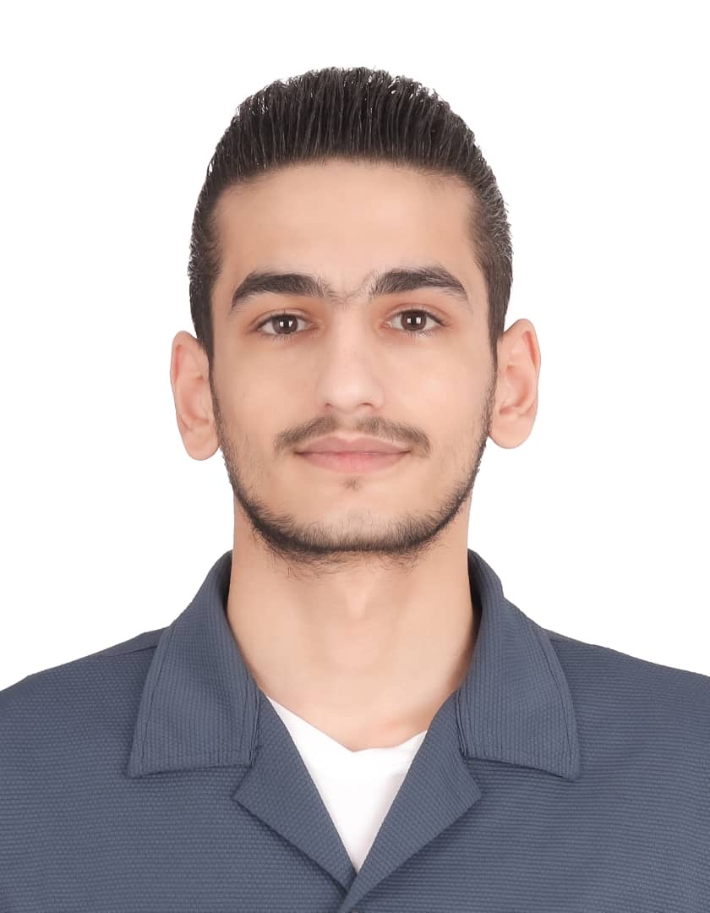
Deaa Naffaa
Location: Dubai | Phone: +971 50 705 9706 | Email: deaanafaa@gmail.com

Professional Summary
Passionate and skilled Fish Butcher with 2 years of experience in seafood preparation, alongside 1 year as a Salad Commis and 1 year as a Waiter. Known for speed, precision, and strong teamwork. Seeking a role in a fast-paced kitchen to grow further in the culinary industry.
Work Experience
Fish Butcher – Azima Seafood Restaurant, Dubai (2021 - 2023)
Expert in cleaning, cutting, and preparing a variety of fish types with precision.
Salad Commis – Azima Seafood Restaurant, Dubai (2020 - 2021)
Assisted the chef in preparing fresh salads, sauces, and garnishes.
Waiter – Azima Seafood Restaurant, Dubai (2019 - 2020)
Provided high-quality customer service and maintained a clean dining area.
Skills
- • Expert in cleaning and cutting fish
- • Quick and efficient in preparing salads and mise en place
- • Strong teamwork and time management skills
- • Basic food safety knowledge
- • Good communication with kitchen staff and customers

